Malgudi Voyage

The **"Malgudi Express"** was supposed to be launched as part of the ongoing "Azadi Ka Amrit Mahotsav" celebration of India's 75th year of independence. It's a beautiful train ride along the Western Ghats through typical southern Indian scenery. You have been approached as their software consultant to develop software that will implement the functionality to calculate the total ticket charge that the passenger will be charged.

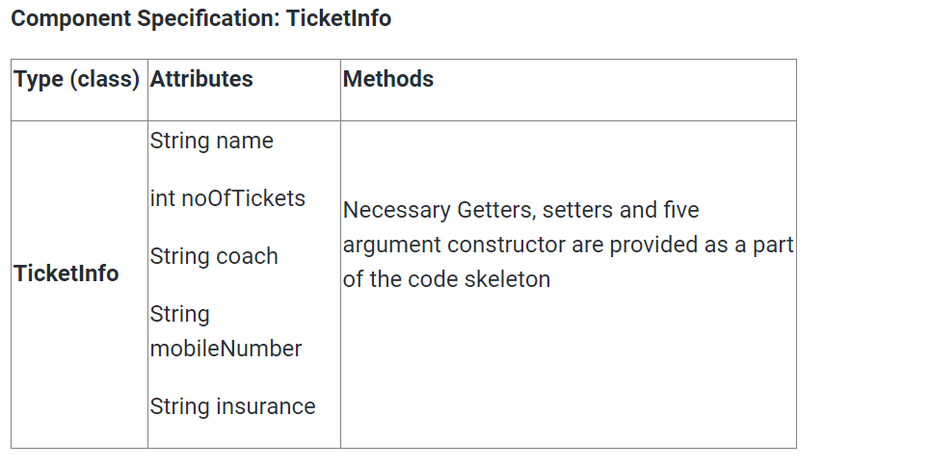

**Formula to calculate Ticket Cost:**

Ticket Cost=noOfTickets*(cost+(cost*5% GST)+(cost*4.5% Service charge))

**Example:** Let cost be 2400,

Ticket Cost=2400+(2400*(5/100))+(2400*(4.5/100))

Ticket Cost=2400+120+108=2628.0.

**Formula to calculate Ticket Booking Cost: (If Insurance required)**

Total Cost=noOfTickets*(Ticket Cost+49).

**Example:**

Total Cost=2628.0+49=2677.0

**The main method in the UserInterface class is excluded from evaluation. You are free to write your own code in the main method to invoke the business methods to check its correctness.**

**Note:**

* In the Sample Input / Output provided, the highlighted text in bold corresponds to the input given by the user and the rest of the text represents the output.
* Ensure to follow the object-oriented specifications provided in the question.
* Ensure to provide the names for classes, attributes, and methods as specified in the question.
* Adhere to the code template, if provided.

**Sample Input / Output 1:**

Enter the passenger details

**Alex:2:FirstAC:8879678456:yes**

Passenger Details

Passenger Name: Alex

Number of Tickets: 2

Coach: FirstAC

Mobile Number: 8879678456

Insurance Required: yes

Total Booking Charge: Rs. 4916

**Sample Input / Output 2:**

Enter the passenger details

**Mary:2:unreserve:8879789656:no**

Passenger Details

Passenger Name: Mary

Number of Tickets: 2

Coach: unreserve

Mobile Number: 8879789656

Insurance Required: no

Total Booking Charge: Rs. 400

**Sample Input / Output 3:**

Enter the passenger details

**Leena:4:TwoTierAC:8890567890:yes**

Invalid Passenger details

**Sample Input / Output 4:**

Enter the passenger details

**David:5:unreserve:9884455661:y**

Invalid Passenger details